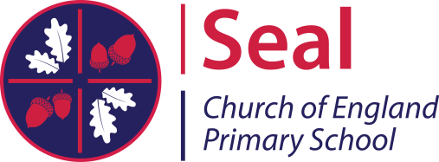
KEY STAGE 2 (YEAR 6) RESULTS 2017

Year 6 2016-17 have achieved an excellent set of results. Progress for reading and writing is above national average and the maths progress score is well above national average placing Seal Primary School in the top 10% of schools in England– pointing to the fact that at Seal CofE Primary School, significant numbers of our pupils make more progress than pupils nationally with similar starting points. (NB: These figures are based on 21 pupils who have data from key stage 1.

Subject | Percentage of pupils achieving at  Seal C of E Primary School | Percentage of pupils achieving  Nationally
Reading, Writing & Maths Combined  % Expected Standard + | 100% | 61%
Reading, Writing & Maths Combined  % Higher Standard | 22% | 9%
Reading % Expected Standard + | 100% | 71%
Reading % Higher Score (110+) | 39% | 25%
Writing % Expected Standard + | 100% | 76%
Writing % Working at Greater Depth | 26% | 18%
Maths % Expected Standard + | 100% | 75%
Maths % Higher Score (110+) | 39% | 23%
Attainment of pupils at Seal Primary school exceeded national figures across all subjects for pupils working at the expected level and at the higher standard

Pupils’ actual test marks converted to ‘scaled score’ where  100+ = ‘Expected Standard’ | Seal CofE Primary School  Scaled Score Average 2017 | National Average  2017
Reading | 109 | 104
Spelling, punctuation and grammar | 109 | 106
Maths | 109 | 104

These results represent the hard work, commitment, dedication and effort on the part of the children, staff and families. School leaders work continuously and tirelessly to monitor, track and develop pupils’ knowledge, skills and understanding so they can reach their full potential (‘Together we achieve and succeed’). We are all very proud of Year 6 and what they have achieved. They focused; they were positive and applied our Christian values to their learning – all these factors contributed to their success.

