Timings: | Activity:
8.45 | Daily zoom session  A chance to see your friends, run through the plan for the day and get ready to learn!
10 minutes | Sensory Circuit
10.05 on tv  Or 10 minutes anytime on BBC IPlayer | CBBC Celebrity Supply Teacher – Gary Lineker  Let’s learn some Spanish today!
15 minutes | Reading  Complete the RWI or guided reading session that you have been allocated. Please contact me if you are unsure or would like to discuss reading.
15 minutes | Mini Maths - arithmetic  Practise counting in 2s, 5s and 10s….  Too easy?!! Try counting in 3s or 4s….  Print off a number line to help you or make your own with the numbers you have to say in a different colour  e.g.  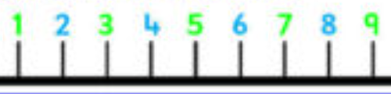
15 minutes | Little Literacy – alliteration, antonyms and synonyms  Please watch these short BBC bite size videos:  https://www.bbc.co.uk/bitesize/topics/zfkk7ty/articles/zq4c7p3  https://youtu.be/miRE6RShEfY
30 minutes | Maths – Division  LO: To be able to understand how to use a concrete method to divide  SC1: I can understand what divide means  SC2: I can use partition a number and represent it with manipulatives  SC3: I can use the manipulatives to do grouping  For todays lesson we are using manipulatives to divide numbers. I have included a video tutorial as well as a worked example.  The questions are attached at the bottom of the page. The diamond ones contain 2 digit numbers, the ruby set 3 digit numbers and the sapphire set 4 digit numbers.  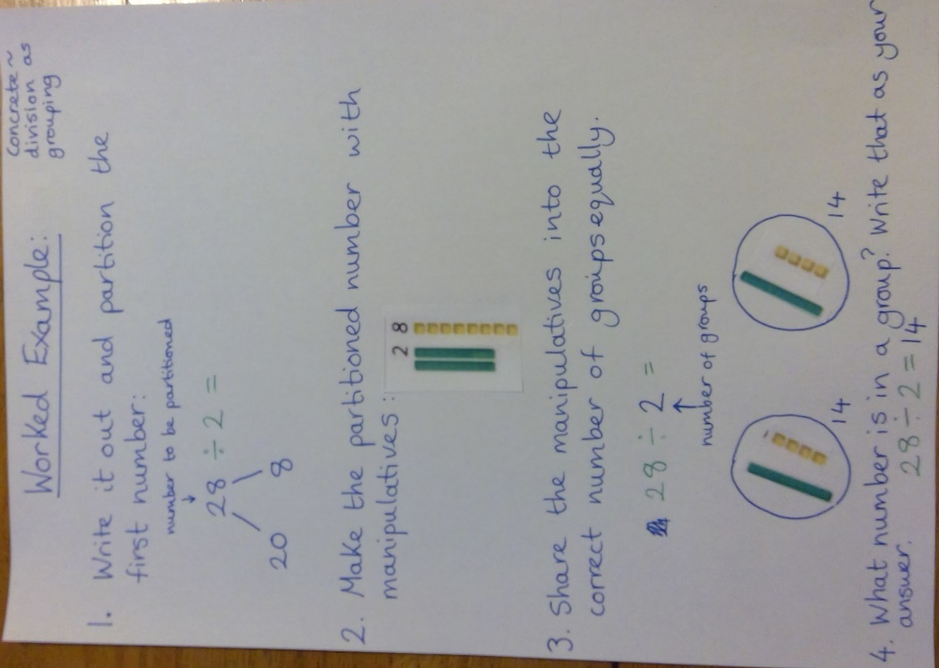
30 minutes | Literacy – Our own Nurture book! – characters  LO: To be able to plan and record initial ideas for a character  SC1: I can use a spider diagram to record my ideas  SC2: I understand the difference between character appearance and personality  Whilst we are learning from home we are going to work through a series of lessons that will result in an exciting outcome – Our very own book based on the Horrid Henry series but featuring us as the characters!  Today’s lesson is to record our initial ideas for the adults that are going to be in our story – ‘Serious Smith’ and ‘Jolly Johnson!’  I will guide you through the planning process step by step in my video. Please see below.
15 minutes | Wellbeing  Please choose one of the wellbeing activities on the main Nurture page. The most recent video will be at the top – part 2 of our school farm!
10 – 30 minutes | CBBC programmes  These can be watched on the tv at the stated times or at any time on BBC iPlayer.  11.05 – Art Ninja – animal costume  11.35 – Operation Ouch – brains and bones!
10 minutes + | Mini indoor challenge – Character sketches  Create some sketches of some of your friends and the adults that are in Nurture in the style Tony Ross uses for the characters in Horrid Henry. Use the link below to get top tips from the illustrator himself!  https://www.theguardian.com/childrens-books-site/gallery/2014/may/27/how-to-draw-horrid-henry-tony-ross
10 minutes + | Mini outdoor challenge – Circuits  Set up zones in your garden with different activities to do for a minute before moving on to the next one:  Possible ideas:  - Throw and catch a tennis ball  - Kick a football into a goal  - Jumping jacks  - Hurdles over jumps made out of sticks or whatever else you can find!

