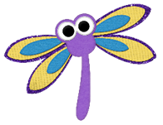
Dragonflies
Wednesday 22nd April
Daily Timetable

9:00am-9:30am | Reading – If you are in Read, Write Inc, Oxford Owl have made available the e-books relevant to your RWI level. You will need to create a login first so please visit:  https://www.oxfordowl.co.uk/user/sign_up.html  Once you have confirmed your login on your email it will direct you to a page that says “Find a book” Please click on that and then follow the instructions below.  Click on e-books and find your relevant book colour to read. Please read the same book 3 times.  1st day – read to decode the words and make sure you can read every word in the book.  2nd day – read the book again and try to read with fluency and expression.  3rd day – read the book again and answer the comprehension questions at the end.  Please take part in the Speed Sounds lesson which is live streamed from:  https://www.youtube.com/channel/UCo7fbLgY2oA_cFCIg9GdxtQ  Set 1 lesson is at 9:30am or 12:30pm (red, green & purple groups)  Set 2 lesson is at 10:00am or 1:00pm (pink, orange and yellow groups)  Set 3 lesson is at 10:30am or 1:30pm (blue and grey groups)  Please email your teacher to find out which group your child is in if you are not sure.  If you are in guided reading, please read the next chapter of Fantastic Mr Fox on our class page and answer the retrieval questions. Please make sure you email this to your teacher.
9:30am-10:00am | Mental Arithmetic  Please practise your division facts for the 2 times table on: hit the button  https://www.topmarks.co.uk/maths-games/hit-the-button
10:00-10:30am | Do a chosen mindfulness activity e.g. drawing, going for a walk (if you can), dancing, listening to music and deep breathing etc.
10:30-10:45am | Breaktime - have a healthy snack and play.
10:45-12:00pm | Maths  L.O. To find 1/3 of a shape, length and quantity (applying).  SC1: I can find 1/3 of a shape  SC2: I can find 1/3 of a length  SC3: I can find 1/3 of a quantity  Watch today’s video tutorial on 1/3. Complete the task set titled ‘Fractions Wednesday 22nd April’.
12:00pm-1:00pm | Lunchtime and playtime
1:00pm-2:00pm | 2020 – A Year of Change  LO – To be able to write an acrostic poem (applying)  SC1 – I can use the features of an acrostic poem in my writing  SC2 – I can use some poetic devices  Today we are going to have a go at writing our first draft of our acrostic poem in our home learning journals. Before we do this I would like you to try and remember all of the features of an acrostic poem. Please can you tell them to someone in your house or write them down in your book. (no peaking at yesterday’s work!)  Please then watch the video tutorial. - https://youtu.be/jjHzruFAuWY  Task 1 – Write your acrostic poem using the word or phrase you chose yesterday from your mind map.  Task 2 – Self assessment – Answer these questions.  Have you used some of the features of an acrostic poem in your poem? If so which one?  Have you used any poetic devices? (alliteration or similes)  Don’t forget to send through a picture of your poem to your class teacher – we are really excited to see them!!  LO: To be able to describe how materials can be used creatively to design a product (understanding)  SC1: I can design a product  SC2: I can explain which materials I would use for each product  SC3: I can explain why I am going to use a specific material for a different part of my product.  Today we are going to have a go at designing our picture which is going to go with our acrostic poem and then eventually be displaying in our windows.  Task 1 – Have a look on the internet to see if there are any images out there that might inspire your picture  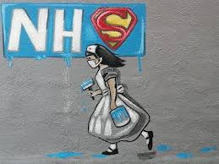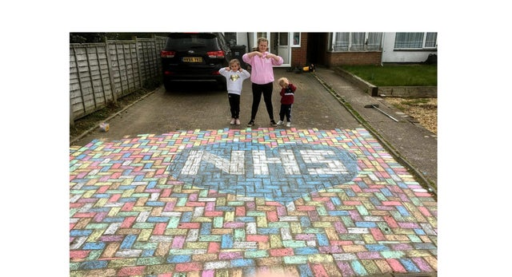  Here are some that I found by googling thing such as “art work supporting the NHS”  If you have a printer you can print these off, if not you can save the ones you want onto a word document to use as inspiration for your collage.  Task 2 – Watch the video tutorial - https://youtu.be/34HaleAgeDU  Now have a go at doing your mind map of all your ideas for you collage. Make sure you label each drawing stating what material you are going to use for which bit and why. Below is my example to help you make sure you are on the right lines.  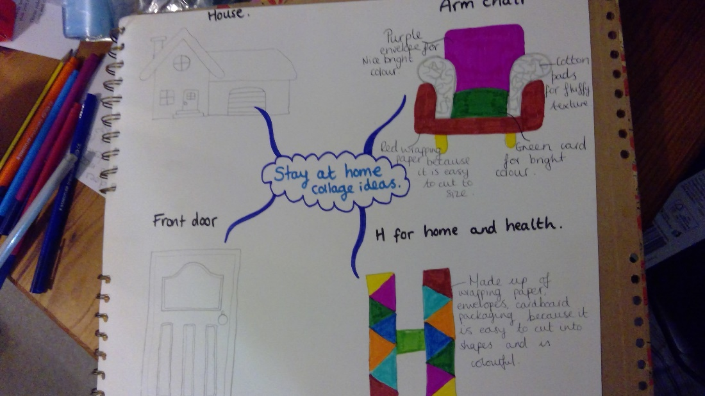  We can’t wait to see your hard work, Don’t forget to send a picture to your teacher.  Task 3 – Self assessment – Answer these questions:  Have you designed some products? (your collage ideas)  Have you detailed which materials from around your house you are going to use to make your designs?  Have you explained on your plan why you are going to use each material for each part of your design?
2:00pm-2:30pm | P.E.  Complete the Joe Wicks Workout:  https://www.youtube.com/watch?v=6v-a_dpwhro
2:30pm-3:00pm  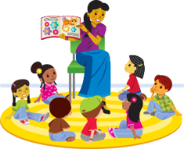 | Story time  Watch a story read by Mrs Clarke  https://youtu.be/apKlfiEksec
Any questions, please email your teacher. Have a great day ☺
We look forward to seeing your fabulous work!

