Colour in 1/3 of these shapes:

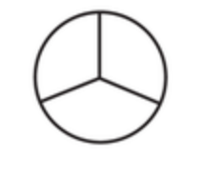
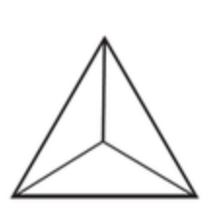

Find 1/3 of these lengths:

15cm | 21cm
6cm | 9cm
30cm | 12cm

Find 1/3 of these quantities:

27 books | 18 sweets | 24 pencils
33 T shirts | 12 Easter eggs

Extension: Find items around your house e.g. crisps, sweets, easter eggs etc and count them. Split them into equal groups of 3 and find 1/3. Draw a picture of it in your learning journal to send to your teacher. If you cannot make equal groups of 3, take 1 or 2 away to make sure that you have enough to split equally.

