Setting 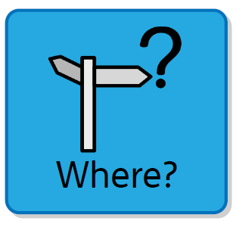
Where in school (inside or outside) would be a good place for our story to take place?

Plot 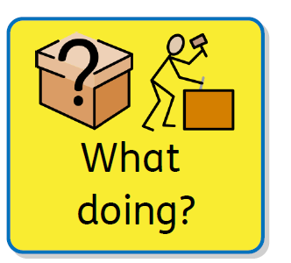
What could happen in the story? Is there a big event or a problem?

Dialogue
Who could be talking to each other? What could they be saying?

