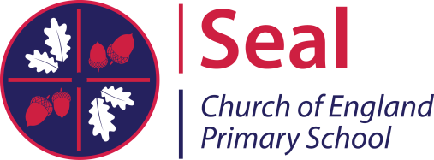
Seal Church of England Primary School
Zambra Way, Seal, Sevenoaks, Kent. TN15 0DJ
Tel: 01732 762388 Fax: 01732 764249
Email: administration@seal.kent.sch.uk
Headteacher: Mrs E. Mitchell

Dear parents/carers,
Every child has the right to food (Article 27)

On Friday 3rd November, we will be having an own clothes day in exchange for donations for the local foodbank, ‘Loaves and Fishes’. This charity helps to provide families with food and essential items in order to stay healthy.
Below are suggested items which the foodbank would gratefully receive:
- Breakfast cereals (but preferably not porridge oats or muesli)
- UHT milk
- Fruit juice (long-life)/fruit squash
- Rice
- Curry sauces/Sweet & Sour sauces
- Tomato ketchup/brown sauce/mayonnaise
- Tinned meat for hot meals (eg minced beef & onion, stew/casserole, chicken in white sauce)
- Fray Bentos pies
- Tinned ravioli
- Tinned macaroni cheese
- Tinned hot dogs
- Spaghetti/baked beans with sausages
- Tinned meat for cold meals (eg ham, luncheon meat, corned beef)
- Tinned vegetables (preferably peas/carrots/green beans)
- Tinned fruit
- Custard/Rice pudding
- Savoury biscuits
- Sweet biscuits/cereal bars
- Coffee/hot chocolate
- Sugar
- Honey/jam/marmalade
- Toothpaste/toothbrushes/toilet rolls
- Tissues/kitchen roll
- Washing-up liquid and laundry cleaning products
[At the moment they have large stocks of tea, pasta, tinned soup, tinned tomatoes, fish and baked beans]
Thank you for your support,
Rights Respecting Ambassadors
(Article 12 – All children have the right to a voice and for adults to take it seriously)

