Butterflies and Dragonflies
Wednesday 20th May

In order to keep up with our time telling skills, whenever you see “WHAT’S THE TIME MR WOLF?” on the timetable, you should stop and tell the time. Record it in your journal so that we can see how you are getting on – parents if you could write a comment to let us know how accurate they were, this would be very helpful. ☺

Timings | Activity
9:00 – 9:30 | Reading – If you are in Read, Write Inc, Oxford Owl have made available the e-books relevant to your RWI level. You will need to create a login first so please visit:  https://www.oxfordowl.co.uk/user/sign_up.html  Once you have confirmed your login on your email it will direct you to a page that says “Find a book” Please click on that and then follow the instructions below.  Click on e-books and find your relevant book colour to read. Please read the same book 3 times.  1st day – read to decode the words and make sure you can read every word in the book.  2nd day – read the book again and try to read with fluency and expression.  3rd day – read the book again and answer the comprehension questions at the end.  Please take part in the Speed Sounds lesson which is live streamed from:  https://www.youtube.com/channel/UCo7fbLgY2oA_cFCIg9GdxtQ  Set 1 lesson is at 9:30am or 12:30pm (red, green & purple groups)  Set 2 lesson is at 10:00am or 1:00pm (pink, orange and yellow groups)  Set 3 lesson is at 10:30am or 1:30pm (blue and grey groups)  Please email your teacher to find out which group your child is in if you are not sure.  If you are in guided reading, please read the first chapter of “George’s Marvellous Medicine” on the class page and complete the task.
9:30 – 10:30am  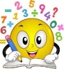 | WHAT’S THE TIME MR WOLF?  Remember to keep taking a diary each time you eat a portion of fruit or veg as you will need this information for Friday’s maths task. Add to the information you kept yesterday.  Maths  L.O. To interpret and construct a tally chart (applying)  SC1: I can explain how a tally chart is constructed.  SC2: I can answer questions based on a tally chart.  SC3: I can create my own tally chart using the features.  Watch this video on tally charts: https://www.youtube.com/watch?v=6L2ch1esFGA  Can you identify the key features? Explain these to an adult. Can you think why we record 5 differently to 1? Why might this be useful?  A tally chart always has a column with a list of the things you are counting, a column with the marks for every time you count one (the tallies) and a frequency column which states the number you have.  Now complete the task on interpreting tally charts on the class page. Choose challenge 1, 2 or 3 on the class page. Challenge 3 is the most challenging.  Now it is time to construct your own tally chart. Make a tally chart which records which drinks you are drinking throughout the day. Watch my video tutorial which models how to do this: https://www.youtube.com/watch?v=7KeYBcIjF34
10:30am-  10:45am | MRS CLARKE NEEDS YOUR HELP!  Every week I have an online quiz with 6 of my school friends and this week I wanted to do the theme “are you smarter than a 6/7 year old?” If you would like to, please could you video yourself asking a question to the camera. Your question could be about something we have learnt this year or about something you have a particular interest in. The funnier place you can record your question the better!  When I have received the videos I will compile all videos together and we can all do the quiz as a fun task on Friday before half term!  Parents – The video will only be shown on a laptop to my 6 school friends and will not be sent to anyone or posted on any social media. If you are happy for your child to take part please can you just write a sentence of consent in the email that you send with their video. aclarke@seal.kent.sch.uk for those of you in Butterflies. Thank you in advance :)
10:45-11:15  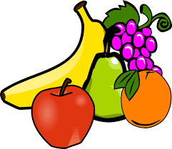 | Breaktime - have a healthy snack and play.
11:15-11:30am  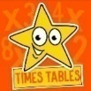 | Mental Arithmetic – 5 x table (division facts – inverse)  Practise your division facts by playing hit the button.  Make sure you select division facts rather than times tables:  https://www.topmarks.co.uk/maths-games/hit-the-button
11:30 – 11:45  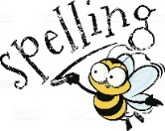 | Spellings  Do rainbow writing with our spellings for this week:  enjoyment, retirement, argument, amusement, payment, movement, assessment, merriment
11:45-1:00 | Lunchtime and playtime
1:00-2:30pm  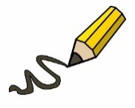 | 2020 – Year of change.  LO: To be able to recall the features of instruction writing (remembering/understanding)  SC1 – I can define a verb  SC2 – I can define an imperative verb  SC3 – I can define a time connective  SC4 – I can list the criteria for writing instructions  Watch the video on what a verb is https://www.bbc.co.uk/bitesize/topics/zwwp8mn/articles/zpxhdxs  Watch the video on verbs to refresh your memory on what a verb is.  https://www.youtube.com/watch?v=ineCCpqpZrM  SC2 – Instructions use something called ”imperative verbs” These can also be known as “bossy verbs” These are verbs (doing words) that instruct you to do something.  Watch the video on imperative verbs to refresh your memory on what an imperative verb is.  https://www.youtube.com/watch?v=oApd0goKJDM  Task 1 - On the class page you will find a document for playing a game of charades.  Ask a member of your family to play with you. Player 1 acts out their imperative verb and player 2 needs to guess. Then swap roles. Player 2 acts out their imperative verb and player 1 needs to guess. Keep score to see who wins. If you have time perhaps you could make up your own imperative verbs to act out.  Task 2 – Watch the video on what is a time connective. https://www.youtube.com/watch?v=Krxj-vIEDbU  Once you have watched the video please can you write your own definition in your home learning journal of what a time connective is.  Please then make a small mind map of all the time connectives you can think of. - remember a time connective is a word that tells the reader when the action is happening.  Please see my example below.  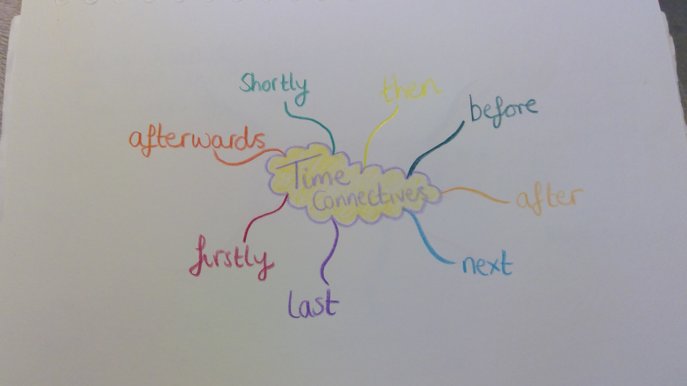  Task 3 – There are a couple of extra things we need to include in instruction writing. Watch the video tutorial to learn these. https://youtu.be/TQ5Vm40t13c  Task 4 – Last task of this lesson is to make a check list of all the things you need to include when writing instructions so that when you write your recipe instructions you can make sure you include all these things.  Please see my example below:  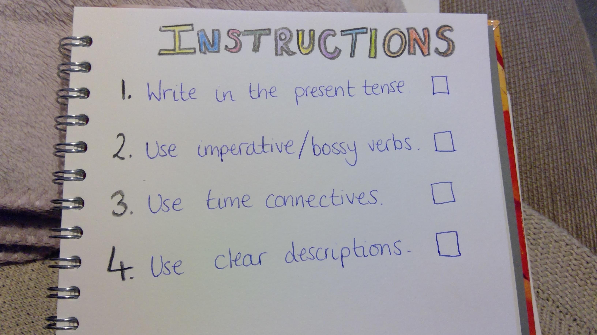  Please send a picture of your time connectives mind map and your instruction writing check list to your class teacher.  Self-assessment questions:  - What is a verb?  - What is an imperative verb?  - What is a time connective?  - What are all the features of an instruction piece of writing  LO: I can identify healthy and unhealthy foods (understanding)  SC1: I can classify healthy foods  SC2: I can classify unhealthy foods  SC3: I can explain how I know foods are healthy or unhealthy  In order for us to be able to create a healthy meal from the food that we have in our cupboards and fridge we need to learn about which foods are healthy and which foods are unhealthy.  Task 1 – On the class page there is a powerpoint on “Healthy eating” Have a read of this powerpoint and answer the questions when it asks you.  Task 2 – On the class page you will find an activity called “food sorting activity. Please could you draw 2 columns in your home learning journal. One column titled “healthy food” and one column “unhealthy food” Then can you draw each of the foods on the activity sheet into the correct column.  Please watch the example below  https://www.youtube.com/watch?v=-8WqgyF5_CA  Please send your class teacher a copy of your table where you have sorted the food, we can’t wait to see your lovely work.
2:30-3:00pm | P.E  Complete the Joe Wicks workout below  https://www.youtube.com/watch?v=uKjcZ8mUr-M
3:00-3:15  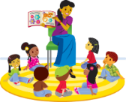 | Story time  Watch a story read by Mrs Clarke:  https://youtu.be/oGJ7oJnICEk  WHAT’S THE TIME MR. WOLF?

