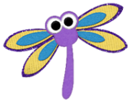

Dragonflies Friday 24th April

Timings | Activity
9:00 – 9:30 | Reading – If you are in Read, Write Inc, Oxford Owl have made available the e-books relevant to your RWI level. You will need to create a login first so please visit:  https://www.oxfordowl.co.uk/user/sign_up.html  Once you have confirmed your login on your email it will direct you to a page that says “Find a book” Please click on that and then follow the instructions below.  Click on e-books and find your relevant book colour to read. Please read the same book 3 times.  1st day – read to decode the words and make sure you can read every word in the book.  2nd day – read the book again and try to read with fluency and expression.  3rd day – read the book again and answer the comprehension questions at the end.  Please take part in the Speed Sounds lesson which is live streamed from:  https://www.youtube.com/channel/UCo7fbLgY2oA_cFCIg9GdxtQ  Set 1 lesson is at 9:30am or 12:30pm (red, green & purple groups)  Set 2 lesson is at 10:00am or 1:00pm (pink, orange and yellow groups)  Set 3 lesson is at 10:30am or 1:30pm (blue and grey groups)  Please email your teacher to find out which group your child is in if you are not sure.  If you are in guided reading, please read the next chapter of Fantastic Mr Fox on our class page and answer the retrieval questions. Please make sure you email this to your teacher.
9:30 – 10:00 | Mental Arithmetic  Please practise your division facts for the 2 times table on: hit the button  https://www.topmarks.co.uk/maths-games/hit-the-button
10:00-10:30 | Do a chosen mindfulness activity e.g. drawing, going for a walk (if you can), dancing, listening to music and deep breathing etc.
10:30-10:45 | Breaktime - have a healthy snack and play.
10:45-11:45 | Maths  L.O. To find fractions of a shape and quantity (deepening)  This week you have learnt what fractions are and learnt to find fractions of a shape and quantity. We have looked at the following fractions individually: ½, 2/4, ¼, ¾ and 1/3.  Today I would like you to consolidate your understanding of fractions by completing two tasks. Task 1 is identifying the fraction of a shape and Task 2 is finding different fractions of different quantities. You can find these tasks on the class page.  If you are not sure and need to re-access any of the video tutorials, please search for these on the Seal Primary YouTube channel.
11:45-1:00 | Lunchtime and playtime
1:00-2:30 | LO: To be able to edit and revise my writing (analysing)  SC1 – I can use my suggestions to improve my writing  SC2 – I can ensure writing uses all features of an acrostic poem.  Today we are going to finish our poem which is really exciting as by the end of the day we will have our artwork and poem ready to be stuck in our window to show our support for the NHS!  Please watch the video tutorial - https://youtu.be/5qbpDRCaL7Y  Task 1 – Now you have watched the video, in your home learning journal can you please have a go at editing and revising your poem, so you are now writing an improved version of your first draft. Be sure to do this in your learning journal not on your neat sheet.  Task 2 - Once you have read through your edited and revised version of your poem and you are happy with it, it is now time to write it up in neat next to your collage. If you used A3 paper then you should have room to write your poem next to your collage, if you used A4 you can use a new sheet of paper or card and then stick it next to your collage.  Please see my example below.  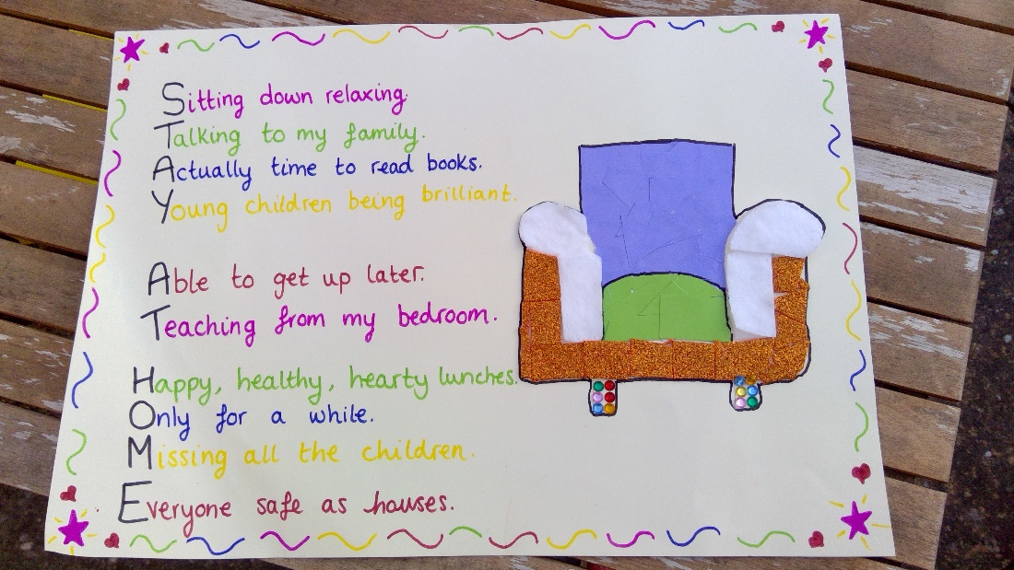  Task 3 - Stick your amazing work in your window for people outside to see! Make sure you take a picture of this and send it to your class teacher so we can see the finished product and send the best ones off to Mrs Mitchell to go on the school website.  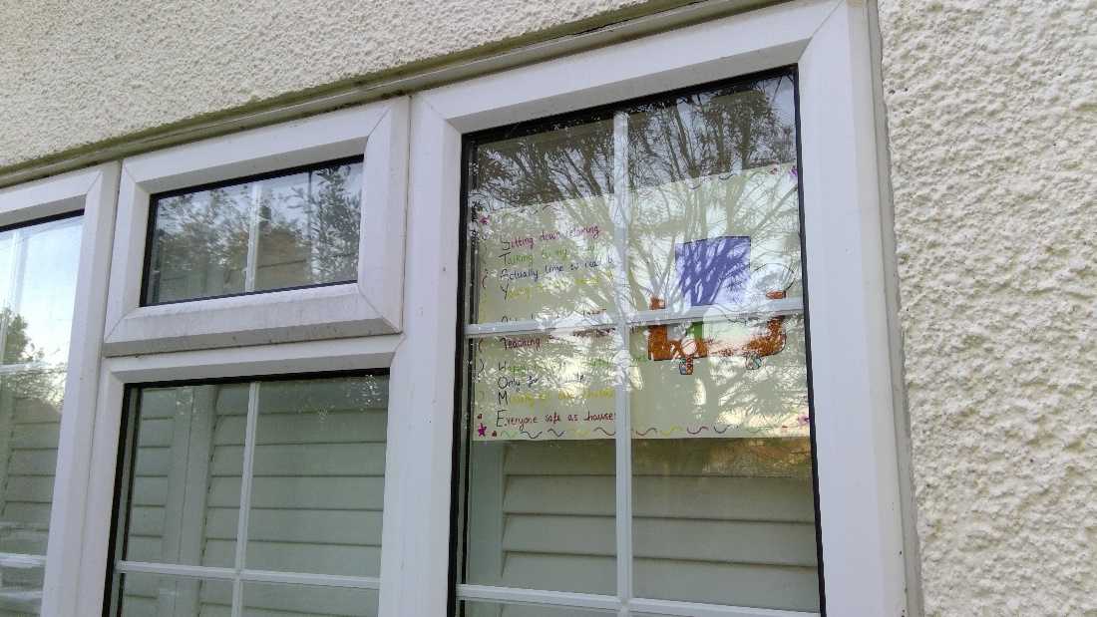  Well done for all your hard work for this week’s “2020 year of change” challenge...let’s see what next week brings
2:30-3:00 | P.E.  Complete the Joe Wicks Workout:  https://www.youtube.com/watch?v=6v-a_dpwhro
3:00-3:15 | Story time  Watch a story read by Miss Theobald.  https://youtu.be/GWM7o5Rappw

